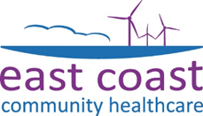
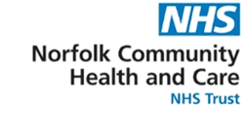

The Community Virtual Ward

‘Hospital at Home’ for patients in Norfolk and Waveney

Patient Information Leaflet
LOOKING AFTER YOU LOCALLY

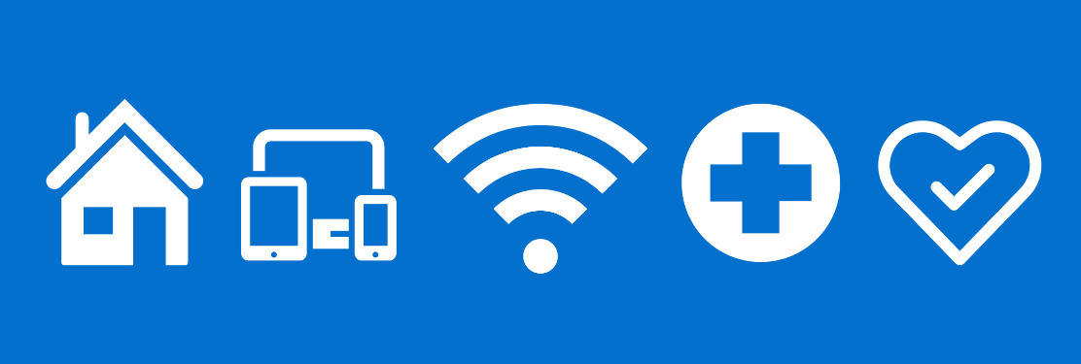
What is the Community Virtual Ward?

The Community Virtual Ward provides care that traditionally takes place in a hospital to patients in the comfort of their own home.

A team of Advanced Clinical Practitioners, doctors, nurses and therapists will oversee your care.

This could be in person, by using remote monitoring equipment, or both.

Why have I been referred to the Community Virtual Ward?

Many hospital services can be provided safely at home. You will be assessed to ensure it is safe for you to be cared for at home.

This may be because the Community Virtual Ward is more appropriate for your needs than going to hospital.

Why is the Community Virtual Ward best for me?

With the Community Virtual Ward, care is tailored to your needs. Being in your own home reduces the risk of hospital-related complications. The Community Virtual Ward helps maintain or regain independence.

Plus, research shows recovery is faster in familiar and comfortable surroundings where you can be with loved ones, eat your own food and sleep in your own bed.

How will my care be managed?

Your care will be managed by an Advanced Care Practitioner who will work with other professionals such as doctors, nurses and therapists to provide the best care for you.

We may need to perform certain tests within your home such as blood tests or heart tracings. We may also need to administer different treatments such as antibiotics to help you get better.

What happens when my treatment ends?

You will be assessed by the medical team before being discharged and referred to a specialist service if needed.

We will send a discharge summary to you and your GP explaining what care you have received. If we have made any changes to your medication, this will be clearly written in your discharge summary.

Any remote monitoring equipment will be collected after discharge by a courier service.

How to contact the Community Virtual Ward Team

If you feel unwell, or for any other queries 8am to 8pm, seven days a week:

Request a call-back using the smart phone included in the remote monitoring kit. We will aim to call you back within 30 minutes.

For urgent clinical issues you can call the Community Virtual Ward team directly on 01603 272575.

If you feel unwell outside of the hours of 8am – 8pm, please call 111.

If it is a life-threatening emergency do not wait, please call 999.

If you would like this publication in large print, Braille, alternative format or in a different language, please contact us on 0800 088 4449 and we will do our best to help.

Feedback

You can receive help with queries about ECCH’s services, or provide feedback about them, by contacting our Patient Advice and
Liaison Service:

ECCH
Telephone: 01502 445447
Email: patientliaison@ecchcic.nhs.uk
(Monday-Friday, 8am-4pm)

We have asked our volunteers to get in touch with some of our patients after discharge by telephone. If you do not want our team to contact you, please let the Community Virtual Ward team know.

You can also tell us how likely you are to recommend our service to friends and family if they needed similar care of treatment. Hearing your views helps our staff understand what they are doing well, and where improvements can be made. Ask a member of staff for a Friends and Family form or visit:

ECCH: www.ecch.org/feedback/take-the-friends-and-family-test-fft/

Produced: East Coast Community Healthcare & Norfolk Community Health and Care NHS Trust
November 2023
Leaflet review date
November 2024
Version 1

